***Famous Quote Quiz***

***Test task***

**General information:**

In the famous quote quiz game system will ask questions and user should try to pick a correct answer. Depending on selected mode user will have to choose correct answer from a list of answers, or simply to answer with Yes/No to the question.

**Task:**

Please create 2 pages:

1. Main page - shows a famous quote quiz
2. Settings page – allows switching between modes.

The user has to guess who the author of the quote is.

The application can function in 2 modes:

1. Binary (Yes/No) – this is the default mode
2. Multiple choice questions – showing three possible answers, one of which must be the right one.

Regardless of the currently selected mode, if the user clicks on the right answer a message is displayed “Correct! The right answer is: ….”; if the user clicks on the wrong answer a message is displayed “Sorry, you are wrong! The right answer is: ….”. Then the answer options disappear and the author name is displayed below the quote. Additionally a button ‘Next’ appears below the author name. When the user clicks ‘Next’ they are navigated to the next quote where they can guess the next quote.

Below you can find 2 wireframes displaying the Main page.

**Note:**

Please start the task and develop the application as much as possible.

It is not compulsory to have finalized solution (especially for junior candidates).

The ability to plan time and split the task will be taken into consideration together with the pure development skills.

For advanced and senior developers – usage of jQuery and Web Services is a plus.

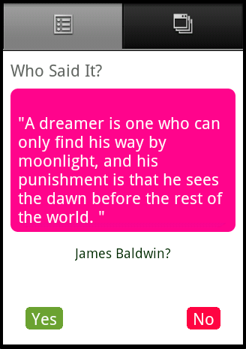 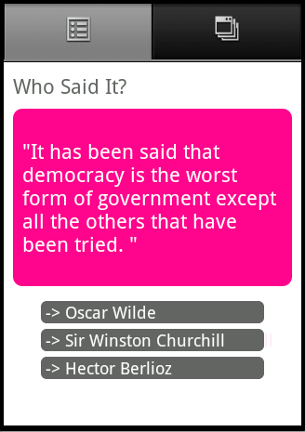

Wireframe 1 Binary mode (Yes/No) Wireframe 2 Multiple choice mode

Deliverables should contain:

* Project Solution
* Backup of the Database
* Short description of the solution
* Please make the application as interactive as possible